COCA

1. Concordance search in COCA

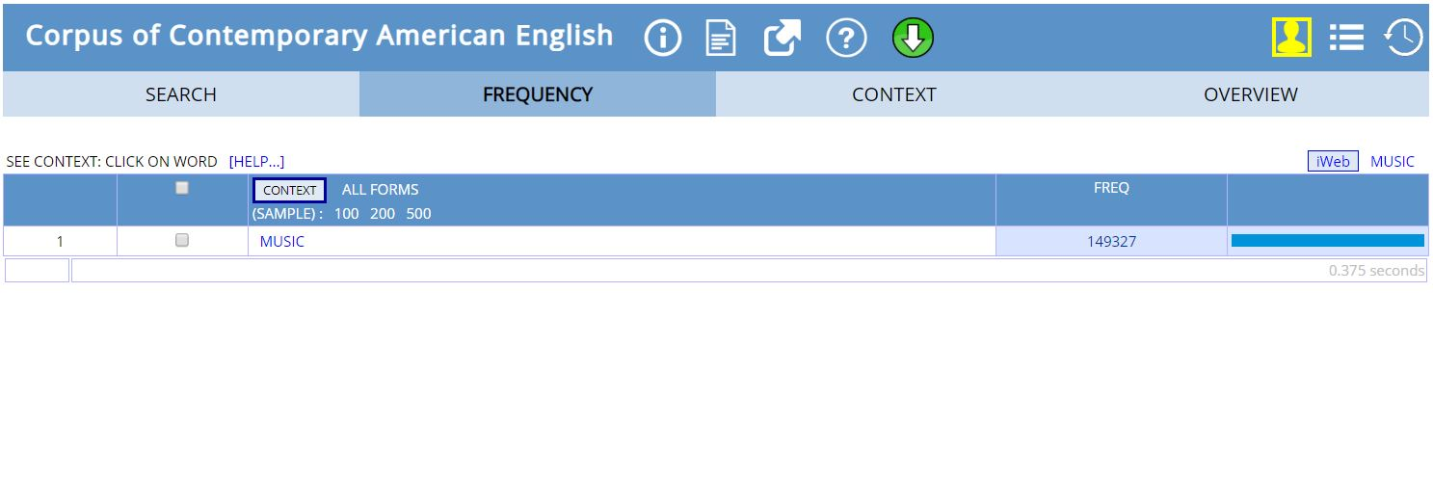

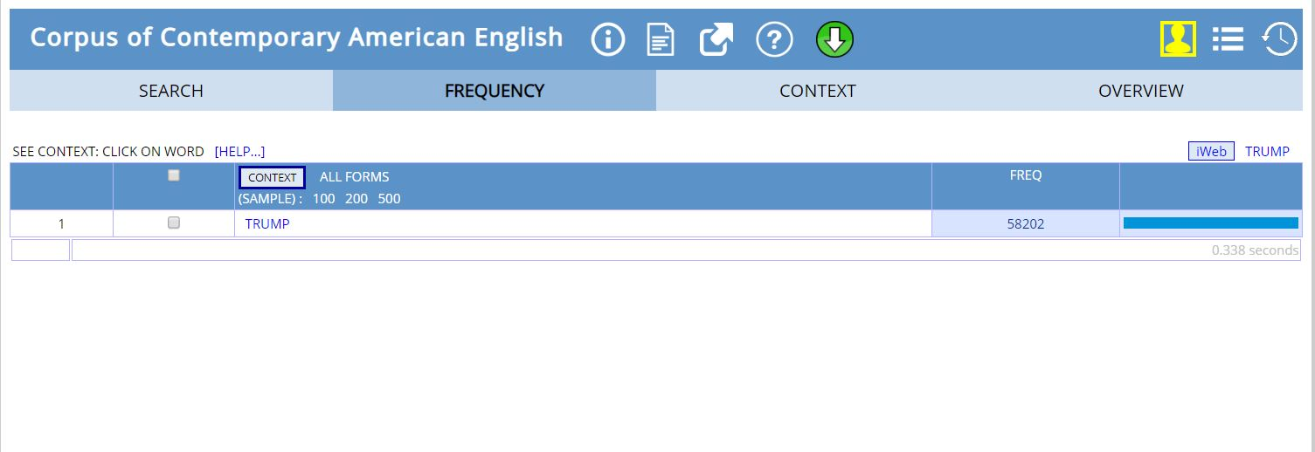

1. Chart

Narendra Modi

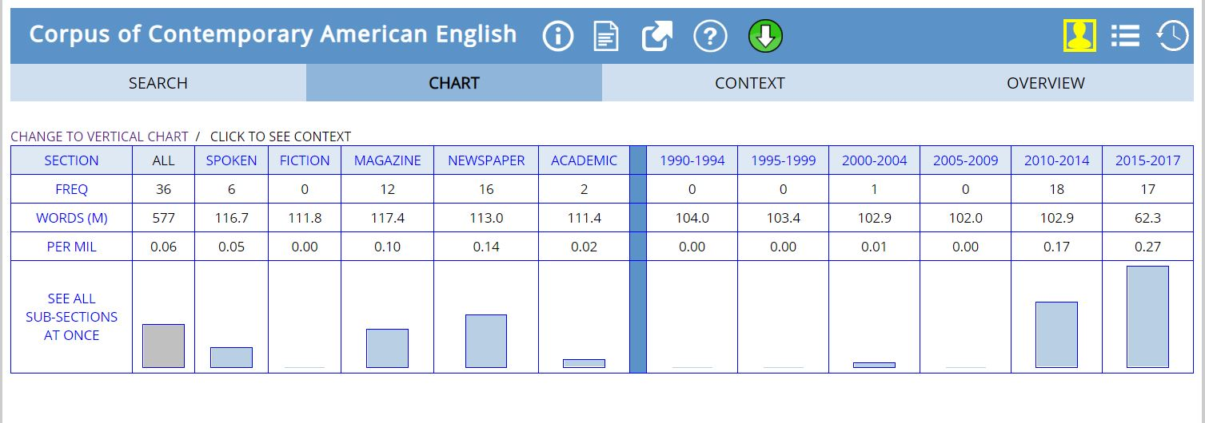

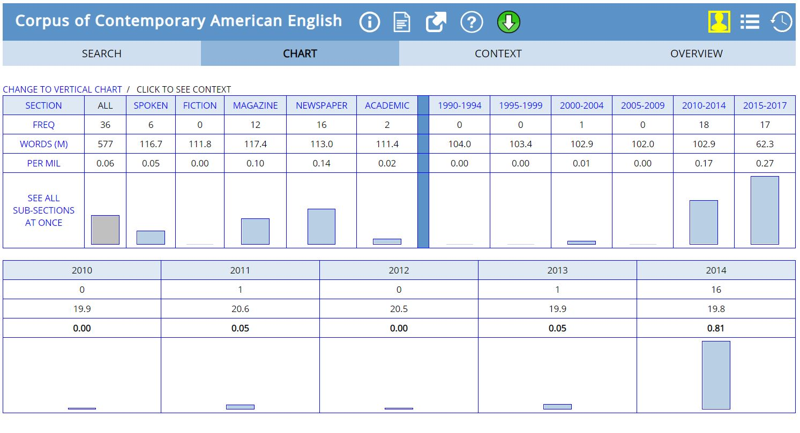

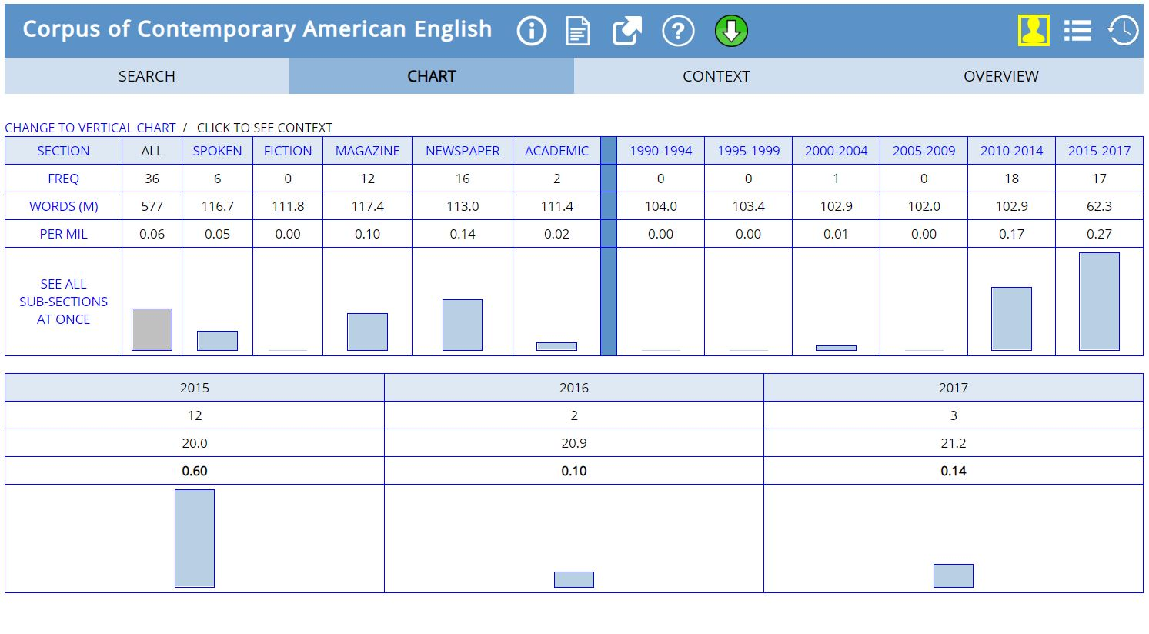

1. Reason

In 2000-2004, Narendra Modi allowed Gujarat 2002 anti-Muslim riots. Mr Modi told officials that the Muslim community needed to be taught a lesson following an attack on a train carrying Hindu pilgrims. He is known to have presided over India's worst religious riots in decades. The riots erupted in 2002 after dozens of Hindu pilgrims were killed in a train fire in the town of Godhra. More than 1,000 people, mostly Muslims, died in the ensuing violence.

In the period 2010-2014, 2014 has the highest frequency because in that year Narendra Modi was elected as the Prime Minister of India. Also, in this year he did many international visits to countries like China, Mongolia, South Korea, Bangladesh, Russia, etc.

In 2015-2017, Modi set up a team to investigate black money. The government demonetized Rs. 500 and Rs. 1000 banknotes, with the stated intention of curbing corruption, black money, the use of counterfeit currency, and terrorism.